HR Analytics Dashboard – Attrition Analysis

1. Project Overview
This project analyzes employee attrition using HR Analytics data to identify the major factors contributing to employee turnover. The dashboard was developed using Power BI after cleaning and preprocessing the dataset. It enables HR managers to monitor workforce trends, evaluate employee performance, and make data-driven decisions that improve employee retention and organizational productivity.
2. Project Objectives
- Analyze employee attrition trends.
- Identify departments with high employee turnover.
- Compare attrition across education fields.
- Evaluate the impact of age, salary, and job satisfaction.
- Build an interactive Power BI dashboard.
- Support HR decision-making using business insights.

3. Business Problem
Employee attrition affects organizational productivity, increases recruitment costs, and impacts employee morale. HR departments often struggle to identify the reasons employees leave the organization. This project aims to analyze workforce data and provide insights that help reduce attrition through strategic HR planning.

4. Dataset Description
The HR Employee Attrition dataset contains demographic information, job-related details, employee satisfaction metrics, salary information, work experience, and attrition status. The dataset includes 1,470 employee records and 35 attributes, making it suitable for HR analytics and workforce analysis.

5. Dataset Features
Explain important columns such as:
- Age
- Attrition
- Department
- Education Field
- Job Role
- Monthly Income
- Job Satisfaction
- Performance Rating
- Overtime
- Years at Company
- Work-Life Balance

6. Tools Used
- Microsoft Excel
- Power BI
- Microsoft Word

7. Data Cleaning
- Checked missing values.
- Removed duplicate records.
- Corrected data types.
- Verified categorical values.
- Validated numerical fields.
- Prepared the dataset for dashboard creation.

8. Data Preprocessing
- Converted categorical values.
- Created calculated columns.
- Standardized column names.
- Formatted numerical values.
- Verified data quality.

9. Exploratory Data Analysis (EDA)
EDA was performed to identify relationships between employee attrition and factors such as age, department, salary, education field, overtime, job satisfaction, and years at the company. Statistical summaries and visualizations were used to discover meaningful workforce patterns.
10. Dashboard Development
The dashboard was created in Power BI using interactive charts, KPI cards, and slicers. The visualizations allow HR managers to explore employee data dynamically and monitor workforce performance.

11. KPI Cards

Total Employees
Displays the total number of employees in the organization.

Attrition Rate
Shows the percentage of employees who have left the company.

Active Employees
Displays the number of employees currently working.

Average Salary
Represents the average monthly salary of employees.

Average Age
Displays the average age of employees.

12. Dashboard Visualizations

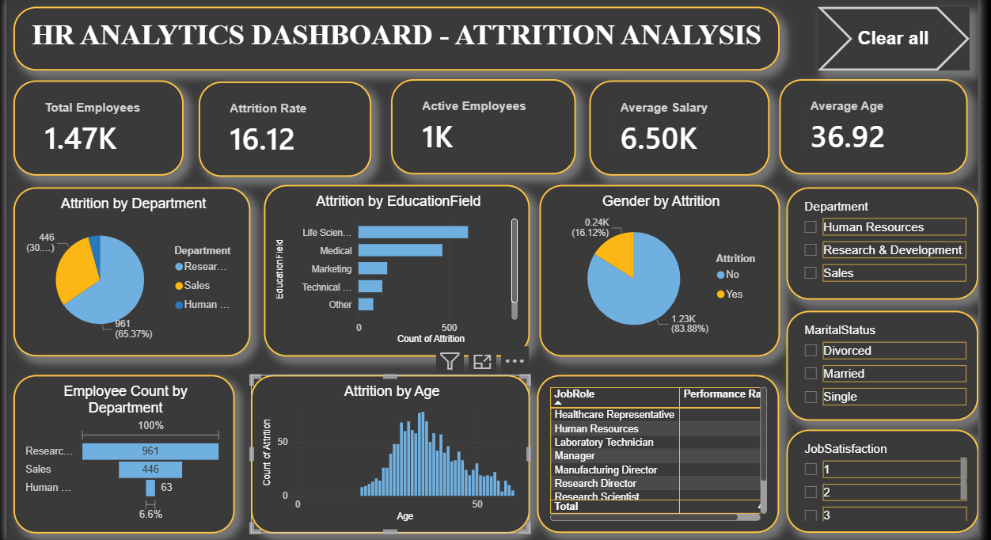

Attrition by Department (Pie Chart)
Shows the percentage of employee attrition across different departments. It helps HR identify departments experiencing the highest turnover.
Attrition by Education Field (Bar Chart)
Displays employee attrition based on education background. This visualization helps determine which educational groups have higher attrition rates.

Gender by Attrition (Pie Chart)
Compares employee attrition between male and female employees, providing insight into gender-based workforce trends.

Employee Count by Department (Bar Chart)
Displays the total number of employees in each department, helping HR understand workforce distribution.

Attrition by Age (Histogram)
Shows employee attrition across different age groups, making it easier to identify which age ranges experience higher turnover.

Job Role & Performance Rating (Table)
Displays employee job roles along with performance ratings. HR managers can evaluate performance trends across different positions.
13. Slicers and Filters
The dashboard includes interactive filters for:
- Department
- Marital Status
- Job Satisfaction
These slicers enable users to analyze employee attrition dynamically based on different categories.
14. Business Insights
- Research & Development has the highest number of employees.
- Employees working overtime are more likely to leave the organization.
- Job satisfaction significantly impacts employee retention.
- Younger employees experience relatively higher attrition.
- Certain education fields show higher employee turnover.
- Employee retention improves with increased job satisfaction and career growth.
15. Key Findings
- Overall employee attrition rate is 16.12%.
- Total employees: 1,470.
- Average employee age: 36.92 years.
- Average monthly salary: 6.50K.
- Research & Development has the largest workforce.
- Job satisfaction plays a significant role in reducing attrition.

16. HR Recommendations
- Improve employee engagement programs.
- Enhance career development opportunities.
- Reduce excessive overtime.
- Conduct regular employee satisfaction surveys.
- Introduce competitive compensation and benefits.
- Strengthen employee recognition programs.

17. Project Outcome
The HR Analytics Dashboard successfully transformed raw employee data into meaningful business insights. It enables HR professionals to monitor employee attrition, analyze workforce trends, evaluate departmental performance, and support strategic decision-making through interactive visualizations.

18. Conclusion
The HR Analytics Dashboard demonstrates how business intelligence tools can be used to improve workforce management. By identifying the major factors contributing to employee attrition, organizations can implement effective retention strategies, increase employee satisfaction, and enhance overall organizational performance.

19. Future Scope
- Predict employee attrition using Machine Learning.
- Integrate live HR database connections.
- Develop real-time HR monitoring dashboards.
- Include employee engagement and performance prediction models.
- Build executive dashboards with advanced HR KPIs.

